**Day1 Assignment (Docker)**

**EC2:** (Elastic compute cloud)

* Amazon ec2 provides Scalable computing capacity in the aws cloud.
* You can use Amazon ec2 to launch as many or few virtual servers or instances as you need, configure security and networking and manage storage
* Amazon ec2 enables you to scale up or scale down the instances.
* Pay for what you use
* Preconfigured template are available known as Amazon Machine image

**Types of ec2:**

**1)General purpose:** General purpose instances provide a balance of compute, memory and networking resources, and can be used for a variety of workloads

**2)Compute optimized instance**: Compute Optimized instances are ideal for compute bound applications that benefit from high performance processors

**3) Memory optimized:** instances are designed to deliver fast performance for workloads that process large data sets in memory.

**4)Accelerated Computing**: Accelerated computing instances use hardware accelerators, or co-processors, to perform functions, such as floating point number calculations, graphics processing, or data pattern matching, more efficiently than is possible in software running on CPUs.

**5)Storage optimized**: Storage optimized instances are designed for workloads that require high, sequential read and write access to very large data sets on local storage.

**Why we use ec2:**

Because it provides scalable computing capacity in the amazon web services cloud. using amazon ec2 eliminates your need to invest in hardware up front , so you can develop and deploy application faster

**Steps to create ec2 instance**

1)first we go ec2 and then click on instances and then click on launch instance and the screen looks like this then we give the name of ec2 and select the image like redhat or windows or linux any image then we select instance type we select t2.micro which is free tier available and then we create key pair and then we choose no of instances we have to create I create 1 instance then click on launch instance

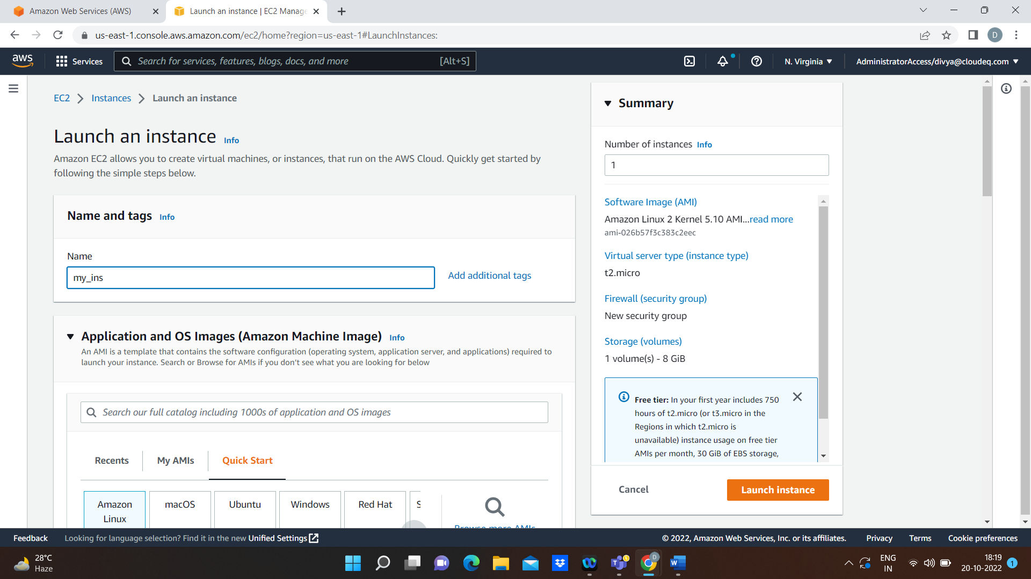

Our instance will be successfully created

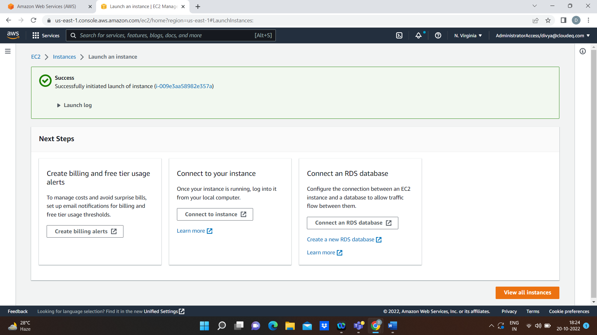

**Docker vs virtual machine**

Docker:

1. Docker is a tool that uses containers to make creation, deployment, and running of application a lot easier. It binds application and its dependencies inside a container.
2. Container have a lot of security risks, and vulnerabilities as the containers have shared host kernel.
3. Docker containers are easily portable because they do not have separate operating systems.
4. The docker containers are suited for situations where you want to run multiple applications over a single operating system

**Virtual machine:**

1. A virtual machine is a system which acts exactly like a computer. In simple terms, it makes it possible to run what appears to be on many separate computers on hardware, that is one computer. Each virtual machine requires its underlying operating system, and then the hardware is virtualized.
2. The virtual machine does no share operating system, and there is strong isolation in the host kernel. Hence, they are more secure as compared to Containers.
3. virtual machines have separate OS, so porting a virtual machine is difficult as compared to containers, and it also takes a lot of time to port a virtual machine because of its size.
4. If we have application or server that need to run on different operating system like windows or linux, redhat, ubuntu then virtual machine are required